1. Declare a div() function with two parameters. Then call the function and pass two numbers and display their division

**Prog –**

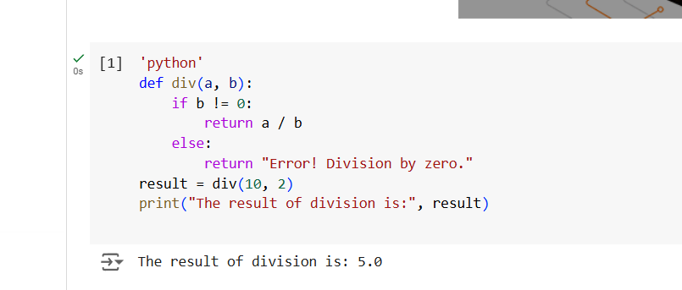

**Output –**



1. Declare a square() function with one parameter.Then call the function and pass one number and display the square of that number
2. **Prog** –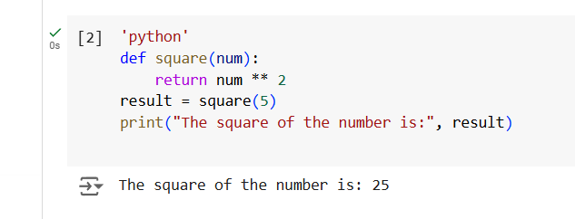
3. 

**Output –**

3. Using max() and min() functions display the maximum and minimum of 5 random numbers.

**Prog –**

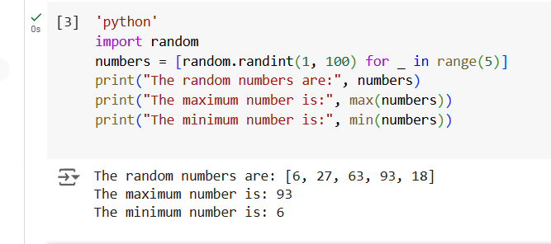

**Output –**



1. Accept a name from the user and display that in lower case using lower() function
2. **Prog –**
3. 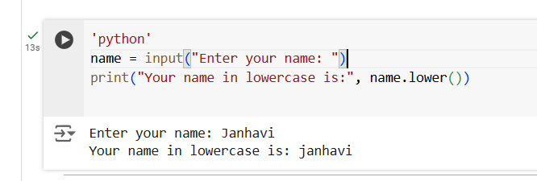
4. **Output** –
5. 